AGENDA - Little Hoole Parish Council  Members of the Council are summoned to the Parish Council Meeting to be held on  Mon 13th April 2026 at 7pm  The Lounge, Walmer Bridge Village Hall, Gill Lane, Walmer Bridge, PR4 5GN  Paul Cafferkey, Clerk & Responsible Financial Officer | 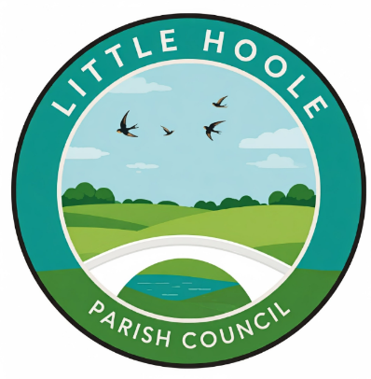
- Apologies for absence
- To agree the Minutes of the last Parish Council Meeting held on the 9th March 2026.
- To receive declarations of interest.
- Matters arising from the minutes of last meeting.
  - Public Time: to invite and listen to issues raised by members of the public.
  - To consider the following Planning Applications:
    - 07/2026/00169/NOT. 42 Great Gill Walmer Bridge PR4 5QP. Install Fixed Line Broadband Apparatus.
    - 07/2026/00159/HOH. The Willows Brook Lane Little Hoole PR4 5JB. Proposed boundary fence and stone driveway.
    - 07/2026/00085/HOH. Dob Lane Nurseries Dob Lane Walmer Bridge PR4 4SU. Retrospective application for the erection of a detached outbuilding to be used as a home office / domestic storage.
    - 07/2026/00054/TDC. 42 Hall Carr Lane Longton PR4 5JJ. Stage 2 Technical Details Consent for the erection of 1no. detached dwelling following Stage 1 Permission in principle application 07/2025/00249/PIP
  - To consider grant application from Little Hoole Primary School PTA in the sum of £4,099 towards the estimated total cost of £12,298 for provision and installation of new lighting and sound system in the school hall.
  - To approve the following transactions in the bank for March 2026.
  - Payments approved by email or pre-approved and retrospectively noted: None
  - Payments for approval: Clerk’s claim for March 2026
  - To approve the Finance Statement as at 31st March 2026.
  - To approve the Asset Register as at 31st March 2026.
  - To review and approve revised wording for the Grants & Donations Policy.
  - Update: re the replacement of the two bus shelters at the junction of Liverpool Old Road and Liverpool New Road (Star Garage).
  - Update re Memory Bench.
  - Update re Pedestrian Access to Longton Health Centre & Library
  - To consider proposal for provision of tree carving on Dob Lane Recreation Park, at an estimated cost of £1,000.
  - Update re Insurance Claim Complaint
  - Discussion re Items to be Insured.
  - Proposal for a Local Campaign to Discourage Dog Fouling.
  - To agree Summer Activities Programme
  - To note fault on Zip Wire, Dob Lane Recreation Park.
  - Update: Summer Planting
  - Information and Updates.
  - Correspondence – none
  - To agree the date, time, and venue for the April 2026 meeting.
Members of the public are welcome to attend meetings to raise any relevant matters. Alternatively, if you cannot attend the meeting but wish to raise a matter or ask a question, this can be done on your behalf by contacting the Parish Clerk (Paul Cafferkey) via email clerk@littlehoole-pc.gov.uk or mobile phone 07966267186.
Visit the Little Hoole Parish Council Website https://www.littlehoole-pc.gov.uk or scan the following QR code.



Prepared and approved by Paul Cafferkey, Clerk – Little Hoole Parish Council,
8th April 2026

